**Leitura e interpretação de textos 2**

**Parts of computers I**

**Inside the computers**

Você já viu algum computador aberto? Nesta aula iremos abordar as peças que compõem a parte interna dos computadores e sua função para o funcionamento pleno de toda a máquina.

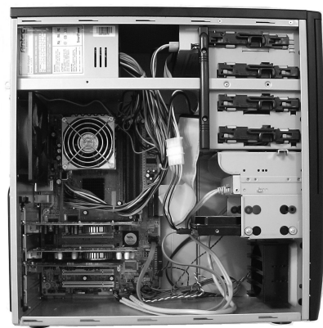

**The case**

The computer case is a very important part of the computer. It protects all

of the electronic components inside and provides adequate ventilation to

prevent overheating. The case also should be capable of allowing you to expand your hardware if the need arises. The ATX case is the one most commonly used today.

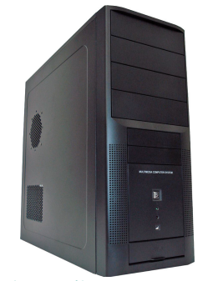

**The motherboard**

A motherboard is the central printed circuit board in many modern computers

and holds many of the crucial components of the system, while providing

connectors for other peripherals. The motherboard is sometimes alternatively

known as the main board, system board, or, on Apple computers, the logic

board.

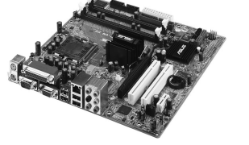

**The power supply**

The power supply supplies the electrical power for a computer. It supplies

power to the motherboard, drives, and certain expansion cards. It normally

has at least one fan that helps cool the power supply and will assist in the

task of cooling the computer.

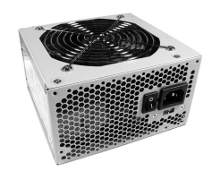

Some power supplies have an additional outlet on the back that can be used to provide power to the monitor. Power supplies come in a variety of wattages. They range anywhere from around 160 watts to about 700 watts. 350 to 400 watts power supplies are probably the most common.

**RAM memory**

RAM is an abbreviation for Random Access Memory. RAM is the computer’s

main memory. The computer uses RAM constantly to temporarily store

information while it is working with it.

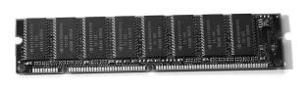

The speed of the memory, or its data transfer rate, is how fast the data can

travel between the RAM and the processor. The speed is measured in MHz

(megahertz). One megahertz is one million frequency cycles per second. Data

travels at a pace of 100 million cycles per second with 100MHz memory.

**The case fan**

Case fans are relatively inexpensive and are extremely important. Computer

components generate quite a bit of heat and must be kept as cool as possible.

The case fan is the primary source of cooling for most computers. Although

the importance of the fan is often overlooked, it is the key to a long life for

a computer. Most computer cases are designed to allow a person to add one

or more additional case fans.

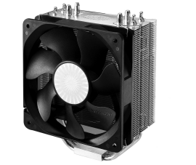

**Hard disk (HD)**

Your computer’s hard disk drive stores information on a hard disk, a rigid

platter or stack of platters with a magnetic surface. Because hard disks can

hold massive amounts of information, they usually serve as your computer’s

primary means of storage, holding almost all of your programs and files.

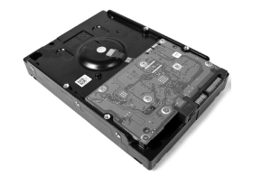

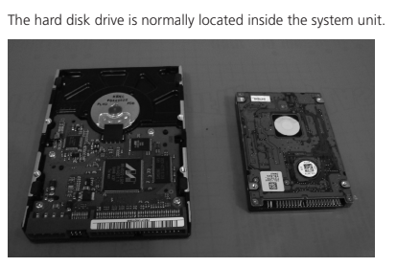

Activities

1. Identify and make a list of the verbs that appear in the **simple present at third**

**Person**

Stores, holds, protects, provides, supplies, has, helps, arises

**Answer:**

2. Transform the follow phrases into negative form:

a) A computer scientist wants to sort the cards.

A computer scientist doesn’t want to sort the cards

b) He wants to order them by number.

He doesn’t want to order them by number

c) Computer science uses special methods.

Computer Science doesn’t use special methods

d) Computer science looks at the theoretical parts of computers.

Computer Science doesn’t look at the theoretical parts of computers

3. Answer the questions about the text

1. Why is the case important?

Because the case protects all of the electronic components inside and provides adequate ventilation to

prevent overheating. The case also should be capable of allowing you to expand your hardware if the need arises.

1. What are the other names for the motherboard?

The other names are main board, system board, or, on Apple computers, the logic

board.

1. How many fans does the power supply usually have? What’s the function of the fan?

It normally

has at least one fan that helps cool the power supply and will assist in the

task of cooling the computer.

1. Can you add extra fans to the case?

Yes. Computer cases are designed to allow a person to add one

or more additional case fans.

1. What is the meaning of RAM?

Random Access Memory. Memory that the computer uses to store

information while it is working with it.

1. Compare HDs and a SSDs:

They both stores information, but SSDs are faster, more durable, consume less power and doesn’t have moving parts inside them like the HDs with the spinning magnetic disks

**Parts of computers II**

**System unit**

The system unit is the core of a computer system. Usually it’s a rectangular

box placed on or underneath your desk. Inside this box are many electronic

components that process information. The most important of these components is the central processing unit (CPU), or microprocessor, which acts as the “brain” of your computer. Another component is random access memory (RAM), which temporarily stores information that the CPU uses while the computer is on. The information stored in RAM is erased when the computer is turned off.

Almost every other part of your computer connects to the system unit using

cables. The cables plug into specific ports (openings), typically on the back

of the system unit. Hardware that is not part of the system unit is sometimes

called a peripheral device or device.

Your computer has one or more disk drives – devices that store information

on a metal or plastic disk. The disk preserves the information even when the

computer is turned off.

**Mouse**

A mouse is a small device used to point to and select items on your computer

screen. Although mice come in many shapes, the typical mouse does look a

bit like an actual mouse. It’s small, oblong, and connected to the system unit

by a long wire that resembles a tail. Some newer mice are wireless.

A mouse usually has two buttons: a primary button (usually the left button)

and a secondary button. Many mice also have a wheel between the two

buttons, which allows you to scroll smoothly through screens of information.

When you move the mouse with your hand, a pointer on your screen moves

in the same direction (the pointer’s appearance might change depending

on where it’s positioned on your screen). When you want to select an item,

you point to the item and then click (press and release) the primary button.

Pointing and clicking with your mouse is the main way to interact with your

computer.

**Keyboard**

A keyboard is used mainly for typing text into your computer. Like the key-

board on a typewriter, it has keys for letters and numbers, but it also has

special keys:

a) the function keys, found on the top row, perform different functions

depending on where they are used;

b) the numeric keypad, located on the right side of most keyboards, allows

you to enter numbers quickly;

c) the navigation keys, such as the arrow keys, allow you to move its

position within a document or webpage.

You can also use the keyboard to perform many of the same tasks you can

perform with a mouse.

**Monitor**

A monitor displays information in visual form, using text and graphics.

The portion of the monitor that displays the information is called the screen. Like

a television screen, a computer screen can show still or moving pictures.

There are two basic types of monitors: CRT (cathode ray tube) monitors and

LCD (liquid crystal display) monitors. Both types produce sharp images, but

LCD monitors have the advantage of being much thinner and lighter. CRT

monitors, however, are generally more affordable.

**Printer**

A printer transfers data from a computer onto paper. You don’t need a

printer to use your computer, but having one allows you to print email,

cards, invitations, announcements, and other materials. Many people also

like being able to print their own photos at home.

The two main types of printers are inkjet printers and laser printers. Inkjet

printers are the most popular printers for the home. They can print in black

and white or in full color and can produce high-quality photographs when

used with special paper. Laser printers are faster and generally better able to

handle heavy use.

**Speakers**

Speakers are used to play sound. They may be built into the system unit or

connected with cables. Speakers allow you to listen to music and hear sound

effects from your computer.

**Modem**

To connect your computer to the internet, you need a modem. A modem is

a device that sends and receives computer information over a telephone line

or high-speed cable. Modems are sometimes built into the system unit, but

higher-speed modems are usually separate components.

1. Mark the correct concept of the following words:

a) Memory

( ) It is what you have to pay when you buy something.

( X ) Enables a computer to store, at least temporarily, data and programs.

( ) When you use the phone to call someone.

b) Mass storage device

( ) Something that tells who a person is.

( ) An area in a business office.

( X ) Allows a computer to permanently retain large amounts of data. Common mass storage devices include disk drives and tape drives.

c) Input device

( x) Usually keyboard and mouse, the input device is the conduit through

which data and instructions enter a computer.

( ) The department that sells a business’s products.

( ) A person from another country.

d) Output device

( x ) A display screen, printer, or other device that lets you see what the computer has accomplished.

( ) To look at many things and then take one or two, as the person wishes.

( ) To write your name.

e) Central Processing Unit (CPU)

( ) To say that you certainly will or will not do something.

( ) A person who is not smart.

( x ) The heart of the computer, this is the component that actually executes

instructions.

1. Transform the phrases into negative form:
2. The keyboard was working.

The keyboard wasn’t working

1. ARPAnet was funded by the United States military after the cold war.

ARPAnet wasn’t funded by the United States military after the cold war.

c) Networks were limited by their nature to only allow communications

between the stations on the local network.

Networks weren’t limited by their nature to only allow communications

between the stations on the local network.

1. Programmers and researchers were using the network computers.

Programmers and researchers weren’t using the network computers.

1. Complete the following sentences with “There is” or “There are”:

a) ......There is.......... a new computer in the store.

b) .......There is........ someone at the house.

c) .......There are......... a lot of absent teachers today.

d) ........There are........ three chairs in the room.

e) .........There are....... two large windows in the house.

f) .......There is......... one table.

g) .......There are......... seven days in a week.

h) ........There is........ no one at home.

i) ........There is........ no problem with it.

**The history of HTML**

**The HTML**

After Vannevar Bush first proposed the basics of hypertext in 1945, it laid the

foundation for Tim Berners-Lee and others to invent the World Wide Web,

HTML (hypertext markup language), HTTP (HyperText Transfer Protocol) and

URLs (Universal Resource Locators) in 1990.

**Definition of HTML**

HTML stands for HyperText Markup Language, it is the authoring language

used to create documents on the World Wide Web. HTML is used to define

the structure and layout of a Web page, how a page looks and any special

functions. HTML does this by using what are called tags that have attributes.

For example <p> means a paragraph break. As the viewer of a web page you

don’t see the HTML, it is hidden from your view, however, you do the results.

Tim Berners-Lee was the primary author of HTML, assisted by his colleagues at

CERN, an international scientific organization based in Geneva, Switzerland.

Tim Berners-Lee is currently the Director of the World Wide Web Consortium,

the group that sets technical standards for the Web.

View a screen shot of Tim Berners-Lee’s Browser Editor as developed in 1991-

92. This was a true browser editor for the first version of HTML and ran on

a NeXt workstation. Implemented in Objective-C, it made it easy to create,

view and edit web documents. Hypertext Markup Language (First Version of

HTML) was formally published in June, 1993.

**Answer the follow questions:**

1. What is HTML?

It’s a text language used to create documents to be displayed websites, it defines the structure and the layout of the webpage

1. How was it created?

Tim Berners-Lee specified HTML and wrote the browser and server software in 1990

1. When was it formally published?

Hypertext Markup Language (First Version of HTML) was formally published in June, 1993

**Prepositions**

As preposições são muito utilizadas na estrutura das frases. Em inglês não

poderia ser diferente. As proposições expressam lugar ou posição, direção,

tempo, maneira (modo), e agente (ou instrumento).

• The keyboard is on the desk - (lugar ou posição).

• Raphael ran toward the hotel - (direção).

• The plane arrived at eleven o’clock - (tempo).

• David travels by train - (maneira ou modo).

• The computer was broken by him - (agente).

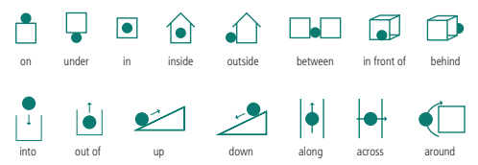

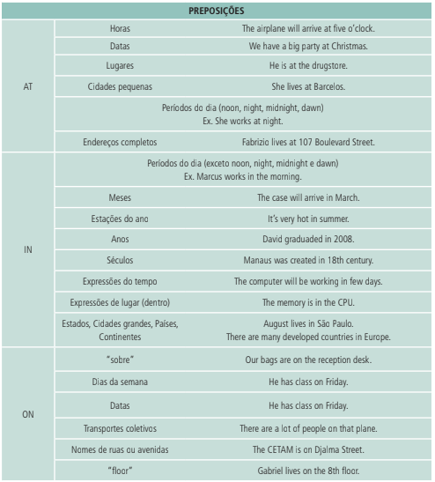

1. Complete with at, in, or on:

a) I am __in___ London.

b) Susan is ___in___ school, but her mother is ___at___ home.

c) The play is going to begin____at_____ 20:00_____on____evening.

d) The monitor is __on___ the table, and the CPU is ___on__ the ground.

e) What are you going to do ____on_____Friday?

f) There was a big parade ____on____ Independence Day.

g) They go to the club ___ by_____ bus but I go there ___on_____ foot.

h) Andres will travel to Brasília _____in___ April.

i) It was very cold ____in____ winter.

j) He lives ___at_____ 598 Konstantin’s Street.

**The history of e-mail**